Lab 04: Getting started with Raspberry Pi
Team Members: Myles Sartor, Prudence Theodorakos, Zachary Silver, Samnorp Deung

Background
The core objective of this lab is to provide you with a practical, hands-on learning experience centered around the Raspberry Pi, a small and affordable computer that can be used for a variety of programming and electronics projects.

Activity Instructions
The instructions can be found in the Assignment in Canvas.

Questions For Reporting Back
Fill in these questions with the responses that you came up with as a team or that we discussed as a class.
- Raspberry Pi and the laptop screen remote connection (insert the photos you capture)
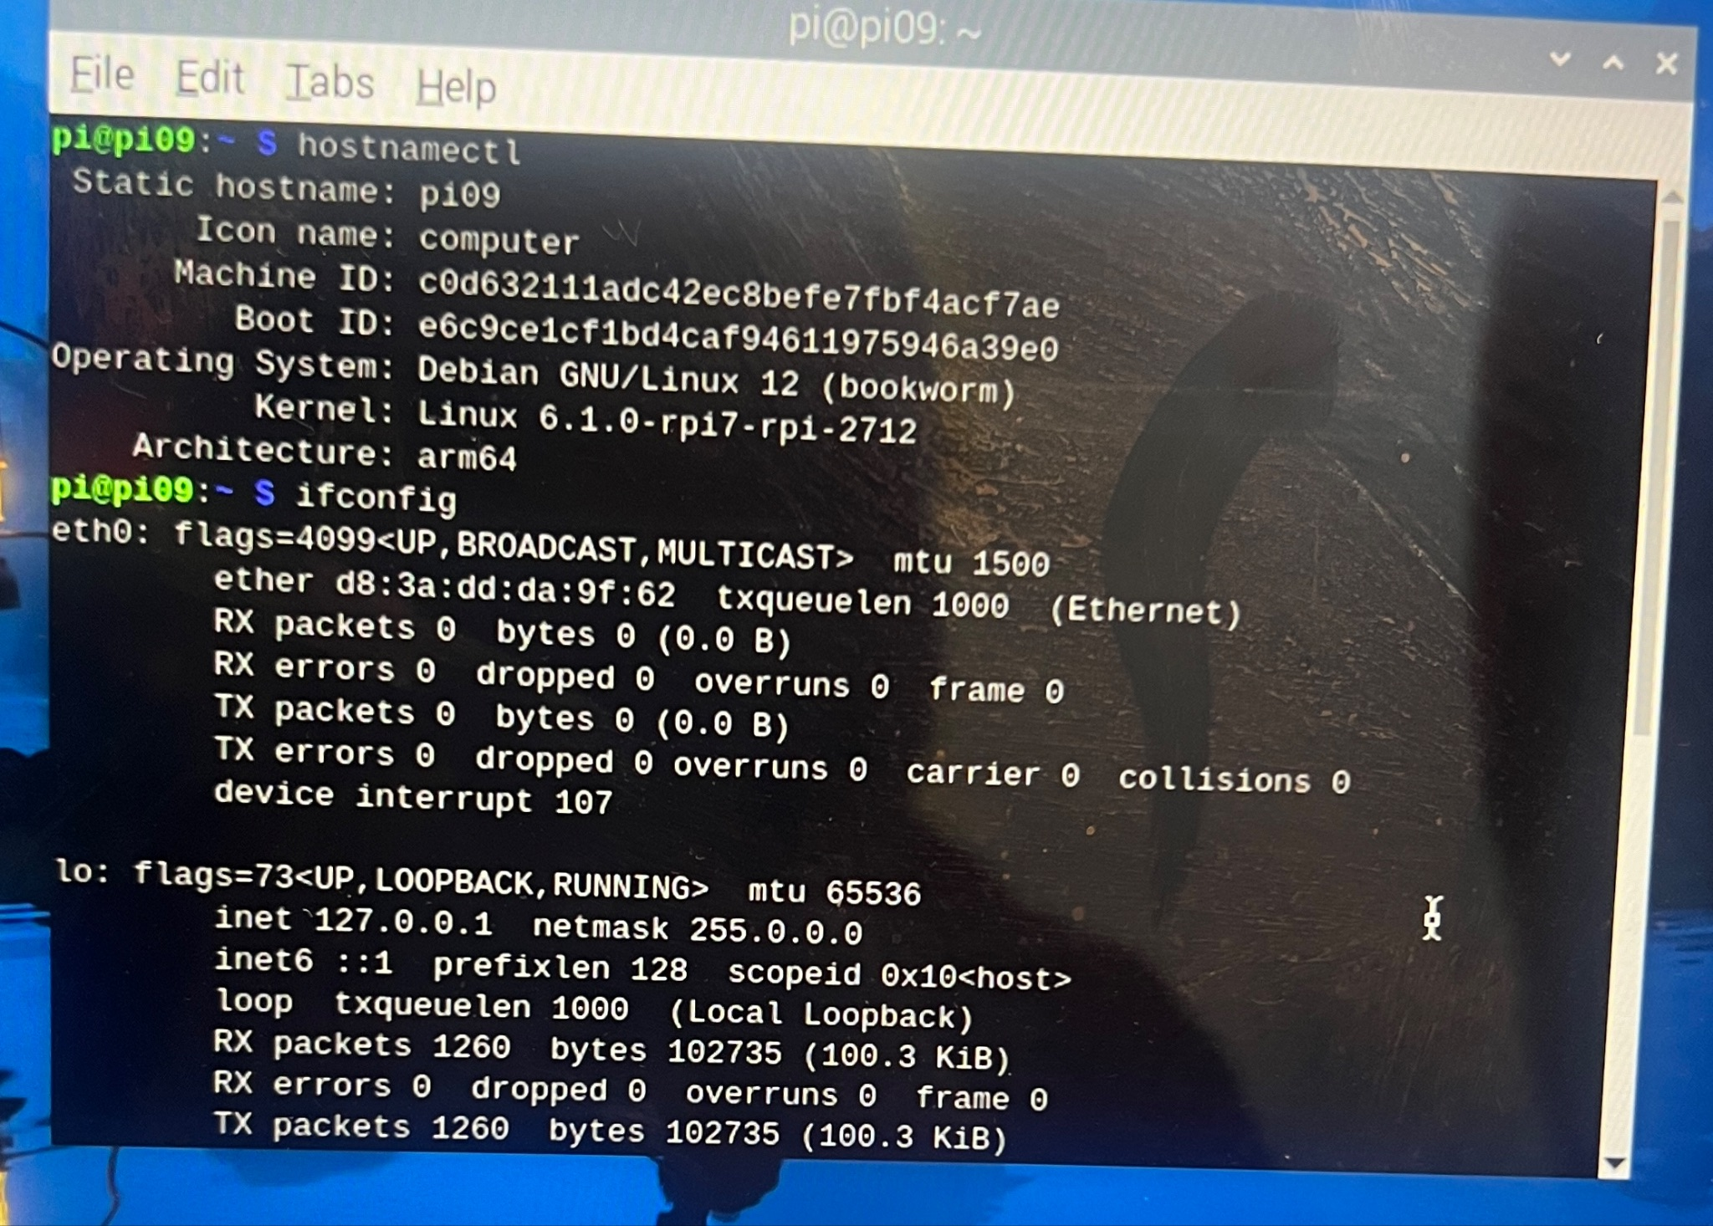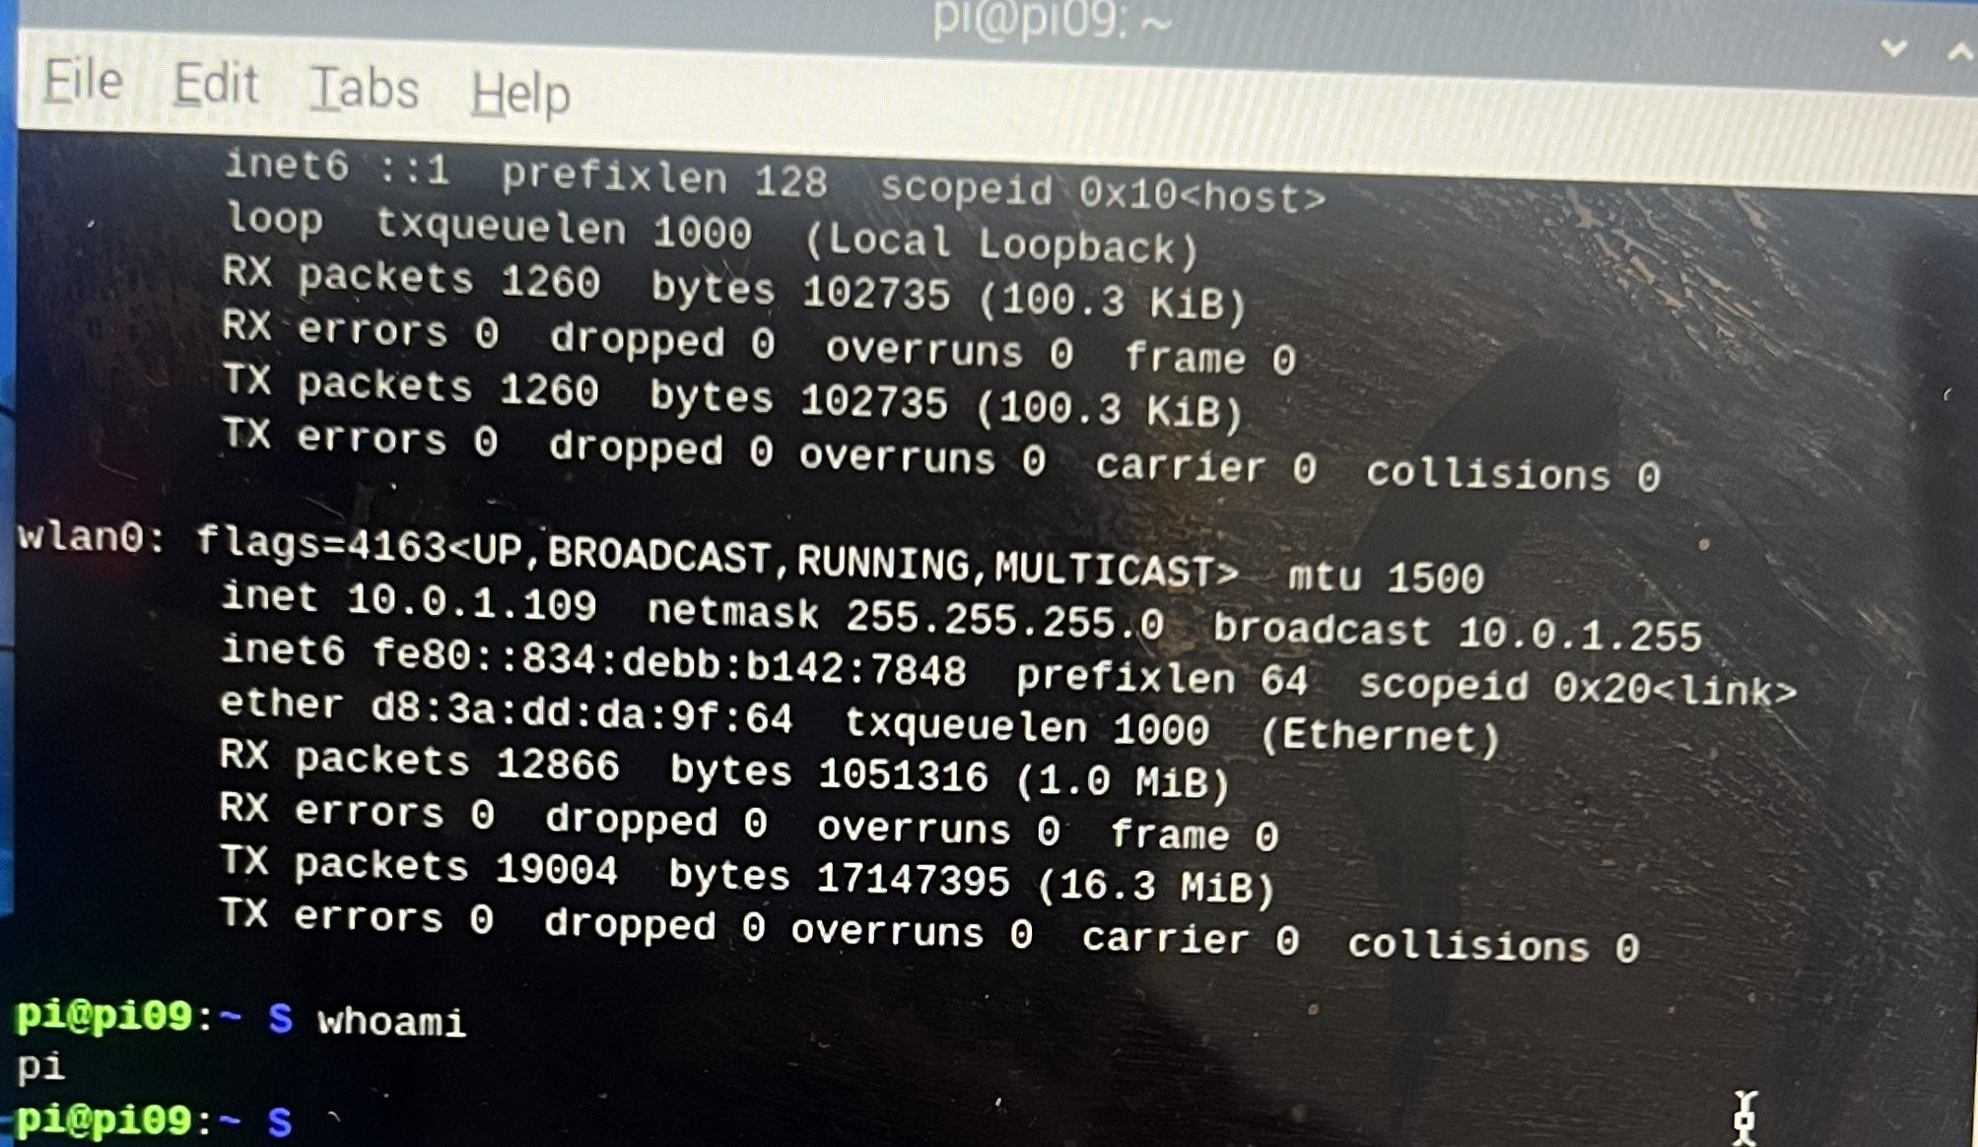

- Sketch, label, and explain how a stack diagrams can help explain applications involved, OSs involved, and hardware involved in this lab.
e.g. Browser used, Raspberry pi OS (Raspbian OS), Raspberry pi, Your laptop with your host OS and the network component.
Stack diagrams allow one to accurately represent the pathway that the laptop takes as it connects with a foreign network in different locations throughout the world. In this scenario, the laptop was utilized to make a connection with the Raspberry Pi and its operating system in order to establish a working session that the user could then utilize for transporting packets.

Potential diagram:
VNC + Safari (browser)
Raspbian OS
Raspberry pi
M1 Macbook (macOS)
Laptop hardware
IPv4 and ping (ms) within network
Tracerouting to another location
Stack(temporary memory area)

- Describe a specific use case for a Raspberry Pi that aligns with your future career interests, explaining its relevance and potential impact. (each person must answer it)
Prudence: Use the raspberry pi as a data repository (would require extra storage)
Sam: Multiple Raspberry pi’s can connect with each other to create a network or stack. Because they are cheap, it can be used as an inexpensive method to set up a system of security cameras to monitor areas.
Myles: Raspberry Pi would aid in my career as a data scientist if I ever need to route certain levels of data or information in the form of packets to potential stakeholders that are depending on us for delivery.
Zack: Using Raspberry Pi as a data repository would be a relevant use for my career. It could be a super helpful tool for data science.

- Why or why not (take a position) should we require students to buy Raspberry Pi for future sections of 346, especially if it will be used in subsequent electives like 348 (Cloud Computing), 365 (Ethical Hacking), and 388z (IoT Design)?
We should not require students to buy a raspberry pi because this contributes to e-waste and costs students money that could be instead taken from the technology fund.

- How does the Pi compare to your laptop? What are the similarities? What are the differences?
The raspberry pi has all the same hardware as my laptop but it is on a single chip instead of spread out across components. There is an obvious size difference between the raspberry pi and my laptop, and my laptop has much more computing power than the raspberry pi. A raspberry pi is much cheaper than a laptop and can start at around $60.

- Map out the network path to the http://hawaii.edu webpage. Starting from your laptop, list all devices and network components you believe were involved in displaying the webpage during the test phase.

After trace routing the direct pathway that my computer takes along the network to hawaii.edu, we found that there were 19 entries of information that displayed where exactly the computer’s packets were going. Entries 10-16 displayed a similar location that is most likely the data center of the university where a majority of the receiving packets reside. The first few entries denote the beginning of the journey as the packets leave off from the computer to the various data points around the University of Maryland.

Potential pathway:
Laptop
Router/Modem
Converging database center
Outreach data points
Final destination (Receiving network points)

